
CS 181L – AICT
Lab # 07
Dropbox

––
Student Name: Athar Imran
Student ID: 2604277

Assignment Date: 28 Oct, 2026
Assignment done: 28 Oct, 2026
Due Date: 28 Oct, 2026

Contents
Part 1: System-Defined String Functions Error! Bookmark not defined.
1. Declare an Empty String and Print Its Size Error! Bookmark not defined.
2. Initialize a String with Your Name and Print It Error! Bookmark not defined.
3. Print the Length of a User-Input String Error! Bookmark not defined.
4. Print Capacity Before and After Appending Text Error! Bookmark not defined.
5. Display Maximum Possible String Size Error! Bookmark not defined.
6. Concatenate First and Last Name Using += and append() Error! Bookmark not defined.
7. Extract the First Word from a Sentence Error! Bookmark not defined.
8. Search for a Keyword and Print Its Index Error! Bookmark not defined.
9. Reverse a String Entered by the User Error! Bookmark not defined.
Part 2: Predefined String Functions Error! Bookmark not defined.
10. Print Length of a User-Input Character Array Error! Bookmark not defined.
11. Copy a String into Another Character Array Error! Bookmark not defined.
12. Concatenate Two Character Arrays Safely Error! Bookmark not defined.
13. Compare Two Strings and Print Which Is Lexicographically Smaller Error! Bookmark not defined.

Task 1 — Sharing a File with Dropbox
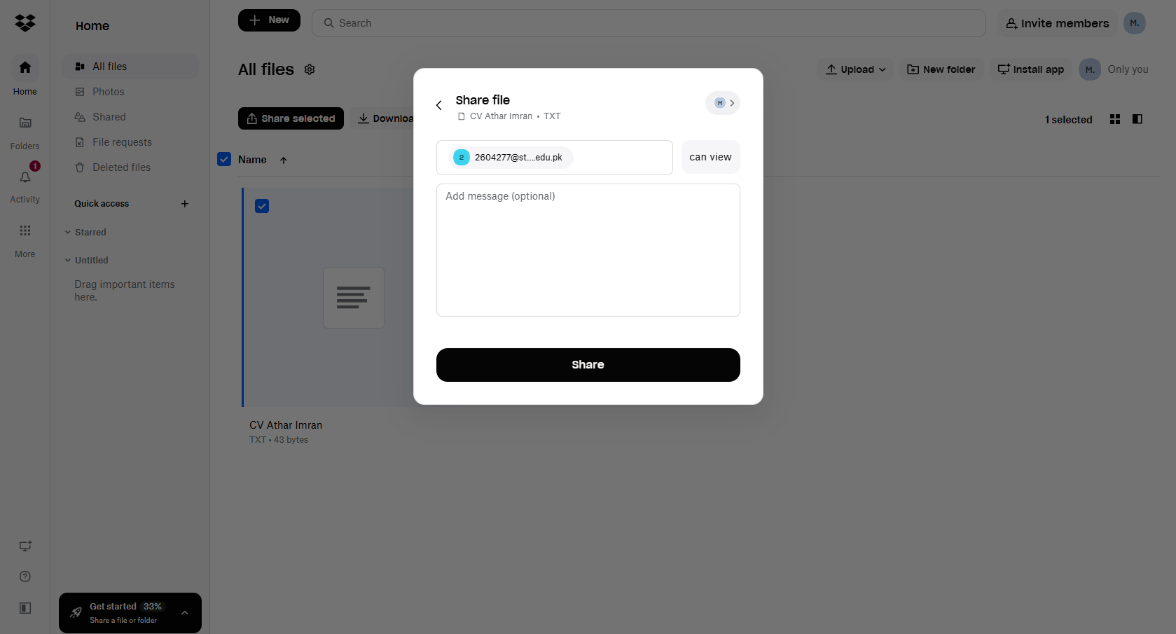
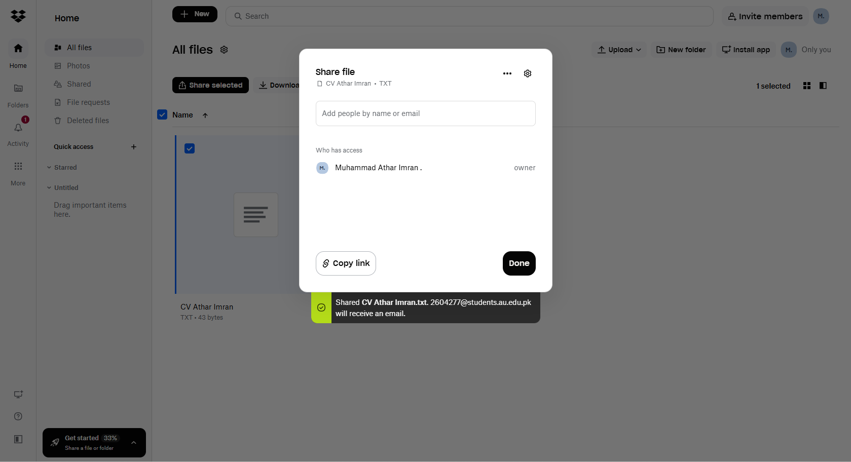

Task 2 — Sharing a File with Google Drive
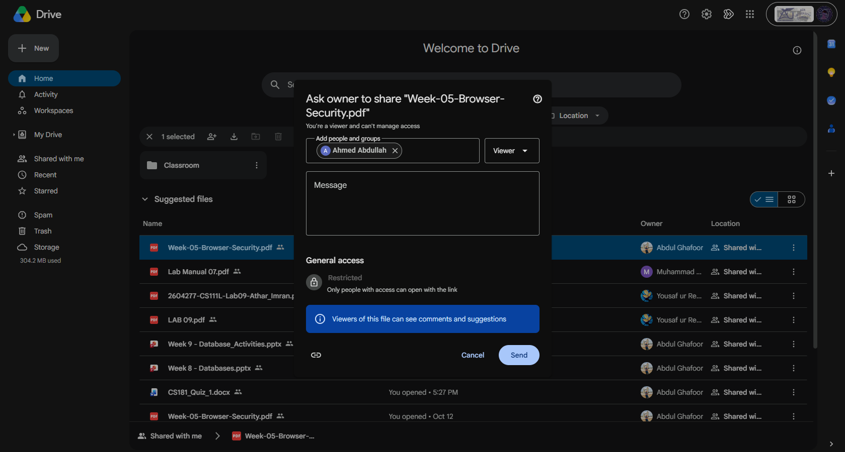

Task 3 — Sharing a File with Microsoft OneDrive
My access to one drive is temporary blocked, while I know how to get task done from One drive.
Upload file, click share, add emails, select access type, and send.

